RALLY IN ANNAPOLIS:
MONEY OUT. . .
VOTERS IN!
CORRUPTION OUT . . . DEMOCRACY IN!
AMEND THE CONSTITUTION!
OVERTURN ‘CITIZENS UNITED’ !
Thursday, January 17, 2013 at 11 am, Lawyer’s Mall in Annapolis
Lawyer's Mall, State House, Annapolis 100 State Cir Annapolis, MD 21401
Featuring huge banners, street theater, humorous slogans, a walking corporation
a beleaguered billionaire, and remarks by legislative leaders!
On the third anniversary of the disastrous ‘Citizens United’ Supreme Court decision which allowed corporations to spend unlimited sums on elections!
We demand that the MD Congressional delegation, and our General Assembly, work vigorously for an amendment to the U. S. Constitution to overturn ‘Citizens United v. FEC,’ and oppose the concept of “corporate personhood.”
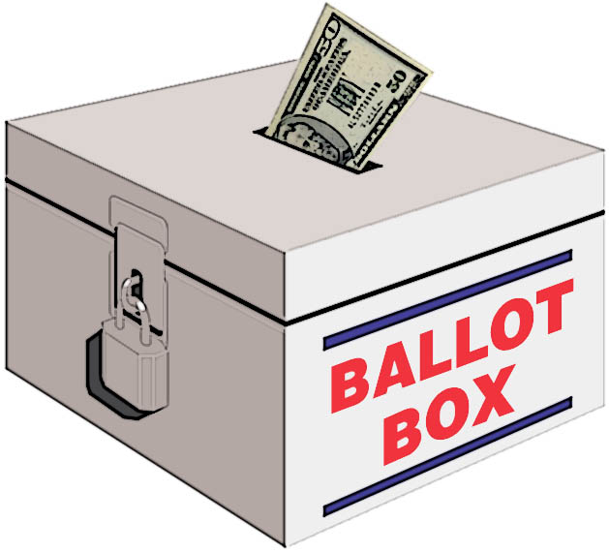
Democracy in our nation is in grave peril from the threat of massive amounts of secret money in politics.
We will send a powerful message that money is not speech and corporations are not people.
On record as supporting such an amendment, are 125 members of Congress, 1 President,
108 members of the Maryland General Assembly, 10 other states, 350 cities and towns, and a clear majority of the public. And in Maryland 5 cities and 1 county.
Sponsored, to date, by Get Money Out – Maryland, Public Citizen, Inc., Maryland Public Interest Research Group, Progressive Maryland, Common Cause Maryland, MoveOn.Org Baltimore Council, Maryland United for Peace and Justice, Progressive Democrats of America – Maryland, Maryland Nonprofits, Fund Our Communities, Prince George's Peace & Justice Coalition, Peace Action Montgomery, Generations for Peace and Democracy, Progressive Cheverly, Howard County Peace Action, Pax Christi, Chesapeake Climate Action Network, United Workers, Pledge of Resistance.
For questions, carpooling, or to help: 410-849-0670 or admin@GetMoneyOutMD.org www.GetMoneyOutMD.org

